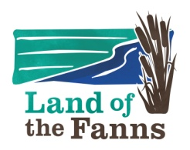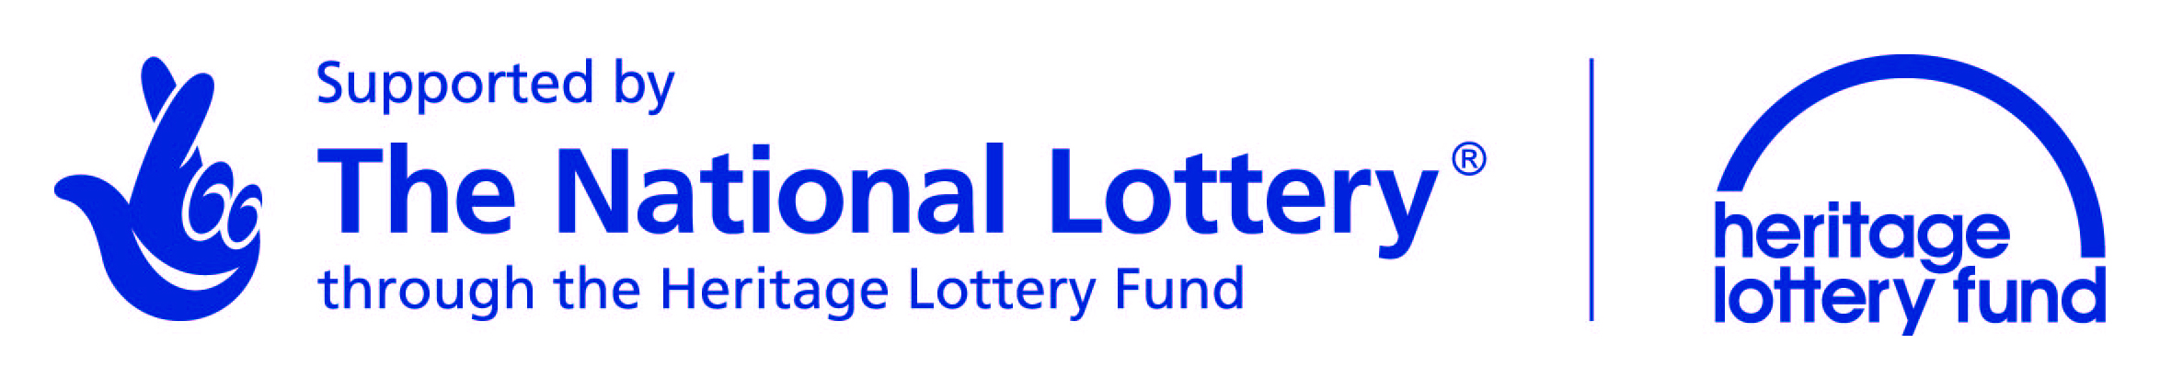
Land of the Fanns Landscape Partnership Scheme
Quarterly Progress Report
NB: Quarterly Progress Reports must be submitted - electronically - to the LotF team whether or not you also put in a financial claim for that quarter.
Quarter (m/y – m/y):

Project Name:

Project Progress
How has your project progressed since your last claim?

What milestones were reached?

Changes to Project
Have there been any changes to your project activities, outputs, outcomes, timetable or budget in the last quarter? If so please provide details:

Has the LotF team been provided with variation requests for the above changes?

Outputs
Please describe your progress in terms of your agreed Project Outputs (refer to schedule 4 of your Funding Agreement). Please attach evidence for each output (see list at the end of this document).
Output | Achieved | Partially Achieved | Not Achieved | List Evidence supplied
If any of the outputs for this quarter have not been fully achieved (or are late starting) what challenges are you facing?

Outcomes
Please describe your progress in terms of your agreed Project Outcomes (refer to schedule 4 of your Funding Agreement). Please attach evidence for each outcome (see list at the end of this document).
Outcome | Achieved | Partially Achieved | Not Achieved | List Evidence supplied
If any of the outcomes for this quarter have not been fully achieved (or are late starting) what challenges are you facing?

Participation and Learning
Please provide information about the participation and learning activities that you have undertaken this quarter (e.g., exhibitions, walks, tours, workshops, lectures).

Please tell us about the numbers and types of people that have taken part in these activities through your project, and what they have told you (eg., schools, community groups, visitors).

Please attach evidence of the audiences you have worked with (including information on age; gender; ethnic background; disability and socio-economic group); include attendees’ lists, feedback forms, photographs, testimonies, etc
Training
What training events have you delivered over the last quarter?

Who has benefited from these training events and how were they received?

Please attach evidence for training events and attendees.
Volunteers
Please describe the numbers and types of volunteers that have been involved, what they have done and how this went. Please attach evidence of age, gender, ethnic background, disability + signing in sheets, feedback or evaluation forms, photographs, testimonies, etc.

Staff
Have you involved any new or existing staff in your projects or any consultants? Please attach evidence (eg., recruitment materials including adverts containing HLF & LotF logos, job descriptions, contracts, application forms, timesheets etc.)

Project Delivery
Will your project be delivered on time?
If no, please explain why and what may be done to address this situation.

Risks
Have you identified any risks that may jeopardise the delivery of your project? What measures are you able to put in place to ameliorate these risks?

Legacy
Are there any long-term maintenance and management issues that have become apparent during your project delivery? How can these be addressed?

Any Further Comments?

Evidence to attach with this report:
Please provide copies of (or evidence for) all visual and written information, evidence and data created and gathered (‘the project record’) during the last quarter that tell ‘the story of the project’, to show what has happened and been achieved as part of the delivery of your project. The LotF team needs to collate these outputs on an ongoing basis to show the HLF how the scheme is progressing.
These could be, job adverts, workshop or training course materials, photographs, videos, DVDs, leaflets, posters, audio recordings, blog posts, art work, project or training diaries, learning resources, maps, interpretation panels, QR codes, apps, exhibition materials, community archives, signage, press releases and press items, workshop materials, websites, Social Media improvements or comments, survey data, TV or radio interviews, articles, presentations, field work data, reports, or quotes of experiences taken from participants, volunteers, visitors or staff involved, etc.
Thank you for taking the time to provide us with the above information!
Your information will be used by the LotF team to compile regular progress reports to the HLF, for ongoing monitoring and evaluation work required for the LotF scheme as a whole, and to promote the LotF scheme and the partners’ work.

