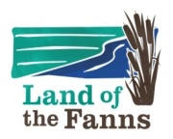
Land of the Fanns – 100 Stories

Story Collecting – Introduction and guidance

The Land of the Fanns Landscape Partnership Scheme aims to restore and reconnect the natural and historic landscape within the area, whilst building understanding and attachment among local people to enjoy and celebrate its special character.

The Land of the Fanns Landscape Partnership Scheme is based on the East London and west Essex border covering parts of four Local Authority areas - London Borough of Borough of Barking and Dagenham, Thurrock Council and Brentwood Council. The partnership also includes Thames Chase Trust, Forestry Commission, Essex County Council, Thames Estuary Partnership and Thames 21.

Community Mapping 100 Stories Project May 2019 – June 2020.

Kinetika is a Purfleet based arts organisation and we are working with Land of the Fanns to deliver a Community Mapping project. We are inviting local people and communities to identify and celebrate 100 Stories gathered in response to the different Landscape Character Areas within the Land of the Fanns area.

Over 2019/2020 participants will be invited to write up the stories, create illustrations, make short audio recordings and films that will be shared on the The Land of the Fanns website.

In the Spring of 2020 participants will turn the drawings in to 100 silk flags using Kinetika’s batik process. The flags and the sharing of stories will form part of the celebratory Walking Arts Festival planned for May/June 2020.

We are collecting in stories. Click here to download a Call Out for Stories and a Story Form for you to write you story on.

Themes

These are the overarching themes of the project and we will group our top 100 stories to reflect them and the 11 Landscape Character Areas.

- The Land of the Fanns is an intricate landscape, full of surprises and hidden gems that rewards exploring.
- It is a crossroad landscape, situated along the Thames, a place where people have always travelled into, through and away from. Journeys.
- The Land of the Fanns is about the shifting relationship between land and water.
- Land of the Fanns is famous for trade, commerce and industry – Human intervention on the Land – People and projects.
Landscape Character Areas

- Havering Wooded Hills, including Bedfords Park
- Langdon Hills and Farmland
- Rainham, Aveley and West Thurrock Marshes, including High House Production Park
- Mardyke, including Davy Down
- Dagenham Corridor, including Eastbrookend Country Park and Vallance House.
- Belhus Lowland Quarry Farmland, including Little Belhus Country Park and Belhus Woods
- Ingrebourne Valley, including Pages Wood, Hornchurch Country Park, Langtons House and Rainham Hall
- Brentwood Wooded Hills, including Thorndon Country Park, Dagenham Park
- Orsett Lowland Hills
- Thurrock Reclaimed Fen including Bulphan
- West Thurrock Quarry Landscape including Chafford Gorges

Land of the Fanns Landscape Character Area map

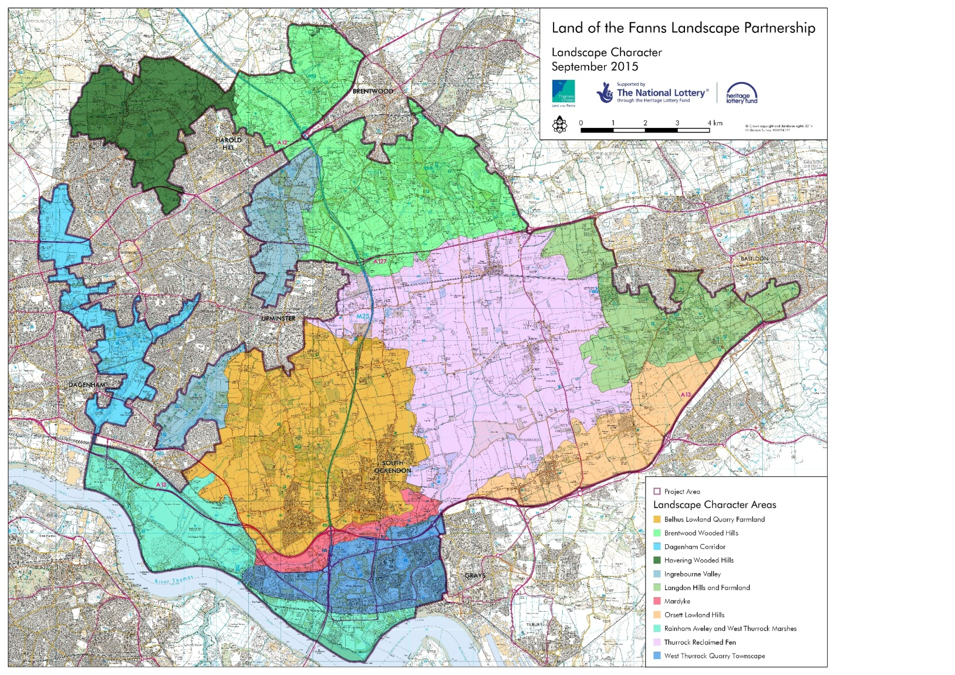

Community Assets

Does your story feature a local building, piece of land or viewpoint which you consider to be of particular value to the local community?

What is a Community Asset?
A community asset is a local building, piece of land or viewpoint which the community considers to be of particular value to the local community. Each community is free to decide for itself what it values. The community assets across the Land of the Fanns area will be mapped and could then be added to local place making frameworks (e.g. local heritage list).
More information on community assets can be found here.

Submit your stories by 19th January 2020 via email to:

jo@kinetika.co.uk

Or post them to:
Jo Beal, Kinetika, 119 Artists Studios, High House Production Park, Off Purfleet Bypass, Purfleet, Thurrock RM19 1AS

Free Drawing and Writing Workshops

Need some more ideas?

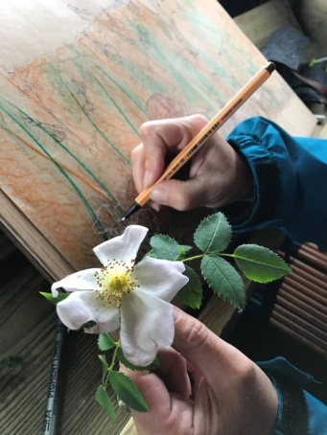
Why not attend these free workshops over winter which aims to inspire memories and stories about your connection to the Land of the Fanns landscape.

Kinetika is running free workshops across the Land of the Fanns and inviting local people to come along and share their tales, histories, myths and legends about the places they live, love or that have special memories for them. There are two different workshops on offer to help gather the 100 stories: informal writing workshops and drawing workshops to help illustrate the stories. The workshops are free and are open to all. No previous experience of story telling or drawing is necessary. The workshops will be led by professional artists: Ali Pretty, Artistic Director of Kinetika and Jo Beal, both of whom are very experienced in working with communities and running friendly, fun, relaxed session for everyone to enjoy and at which to feel welcome. They will help illustrate the stories in a simple, bold way, so that the illustration can be used as designs for silk flags.
Check for updates and book here.

