**Submit your stories by 19th January 2020 by email to**: [jo@kinetika.co.uk](mailto:jo@kinetika.co.uk?subject=Story%20Submission)

Or post to: Jo Beal, Kinetika, 119 Artists’ Studios, High House Production Park, Artisan Way, Off Purfleet Bypass, Purfleet, Essex RM19 1AS

If you want to chat anything over, please call either:

Aisling Woodhead (Land of the Fanns) 01708 642978

Jo Beal (Kinetika) 07966 431467

Use the space on the next page to write down your story (500 – 1000 words)

Some handy tips for you to get started:

* What’s your top story? Give it a title
* What is it about? Describe the landscape.
* Where does it take place – a visual description, colours, smells, sounds.
* What’s beneath your feet, what’s around you, what’s on the horizon?
* Can you see the River, a lake, a pond?
* Are there any insects, birds, creatures moving around?
* Is the story about the past, the present or the future? Or all of the above?
* What the main object, who is the main character – describe them.
* What were they doing, what are they going to do?
* What did they say, did you have a conversation? Capture a quote.
* Did the landscape/the person have an impact on you?
* How do you feel about your story/the experience you had visiting the site?
* Do you have a role in looking after it? Would you like to be more involved with protecting its future?
* Does your story feature a local building, piece of land or viewpoint which you consider to be of particular value to the local community? Find out more about what a Community Asset is [here.](http://www.landofthefanns.org/projects/b2-2-community-mapping/)
  + When you email your story, why not also send a drawing – which could be a simple map or diagram, or an illustration of nature, wildlife or a building.
  + Or email a photo with your story that helps illustrate it, and give it a caption.
  + Remember to add your name and contact details to the form before submitting.

**Land of the Fanns – Story Form**

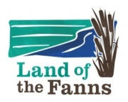

**Your Story Title:**

**Which landscape theme best fits your story?**

The Land of the Fanns is an intricate landscape, full of surprises and hidden gems that rewards exploring.

It is a crossroad landscape, situated along the Thames, a place where people have always travelled into, through and away from. Journeys.

The Land of the Fanns is about the shifting relationship between land and water.

Land of the Fanns is famous for trade, commerce and industry – Human intervention on the Land – People and projects.

**Write your Story here:**

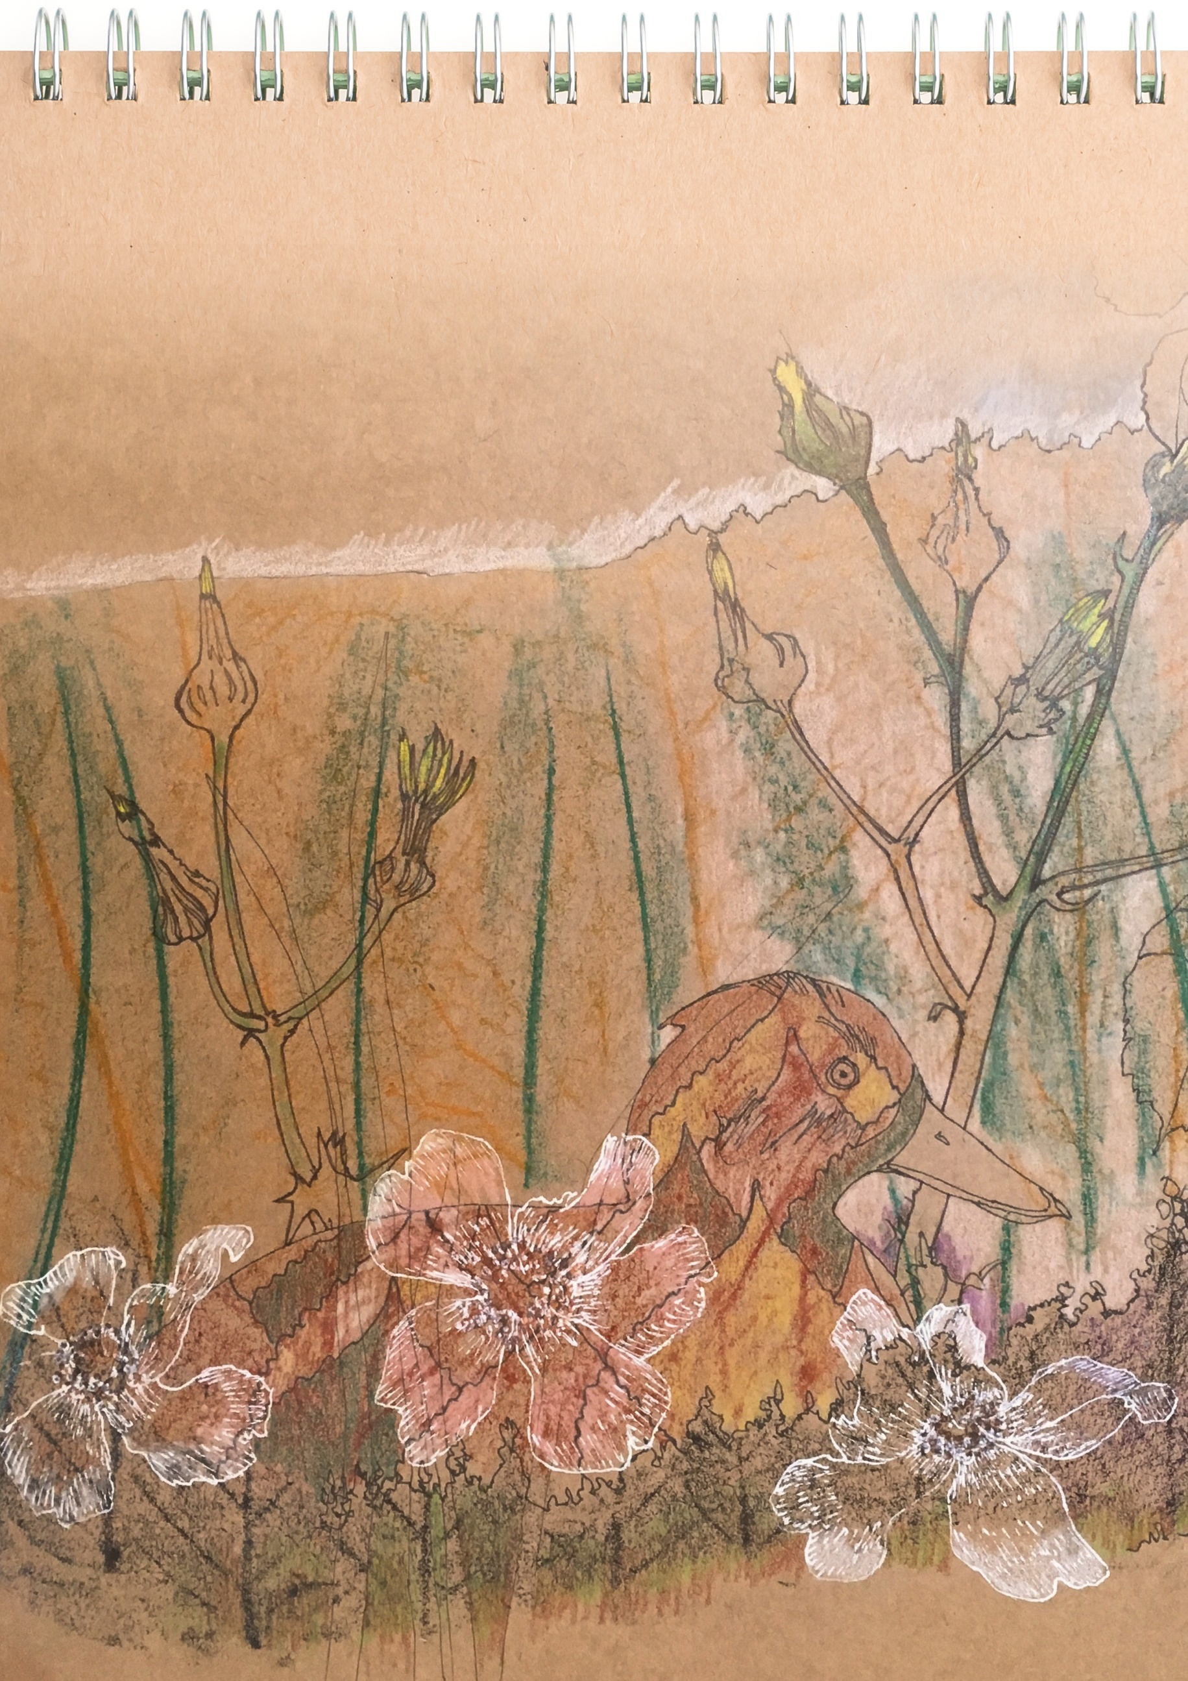

**Write your Story here:**

**Continue your story here:**

**Your Name:**

**Address:**

**Postcode:**

**Phone number:**

**Email:**

**Age:** 0 – 12 13-18 19-26 27 – 64 65+





