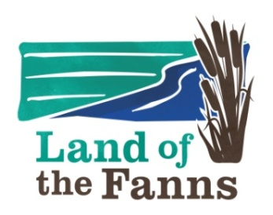
Land of the Fanns Partnership Scheme 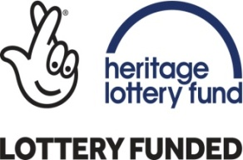
Community Action Fund
Background Information & Guidance Notes
We strongly recommend that you read this document and the Frequently Asked Questions before completing the application form.
Application forms can also be found at: www.landofthefanns.org/community-grants
INTRODUCTION
Background
It was Leslie Thompson who first coined the phrase, ‘The Land that Fanns’ in his local history study in 1957 which celebrates a more unified landscape. ‘Fanns’ is derived from the Saxon word for fen which meant ‘low marshy land or low-lying district’ which perfectly describes much of the area. There are frequent references in his book to the fann men of this area; their work in managing this marshy landscape and their lifestyle during the 17th and 18th centuries, taken from local parish records from Rainham in the west to Canvey Island in the east. Thompson was amused by the fact that the land even appears to fan out from the panoramic view at Langdon Hills and hence gave rise to his book title.
Shaped by the ice age and historically an area of fens, forests and farming, the landscape hosts an unusual variety of niche landscapes including highland, lowland, marshes and river valleys. Each of its 11 landscape character areas has attracted its own history, collectively making up a surprising landscape of diverse heritage with sites of national importance often overlapping with the national story.
The landscape is rich in heritage from landscape to biodiversity; to its buildings and archaeology, as well as its human communities, including the arts, religion and engineering.
Whilst the project has taken this phrase and used it to cover an area encompassing more than just historic fenland, the title still retains a ring of truth about it. Indeed the wider landscape owes so much of its character to a marshy origin that it becomes appropriate. By adopting the historic name coined locally for this area, the ‘Land of the Fanns’ also captures the essence of the project’s ambition: to reunify the landscape and spark renewed attachment to it. We want to take our landscape partners and communities on a five year journey to build understanding, strengthen attachment and celebrate what is special about our area and to leave a lasting legacy for future generations.

About the Land of the Fanns Partnership Scheme
The partnership is made up of 5 local councils, The London Borough of Barking and Dagenham, The London Borough of Havering, Thurrock Council, Essex County Council and Brentwood Council and joined by partner organisations such as Thames Chase Trust (Lead partner), Forestry Commission, Thames21 and Thames Estuary Partnership.
Map showing the Land of the Fanns Landscape Project Area.
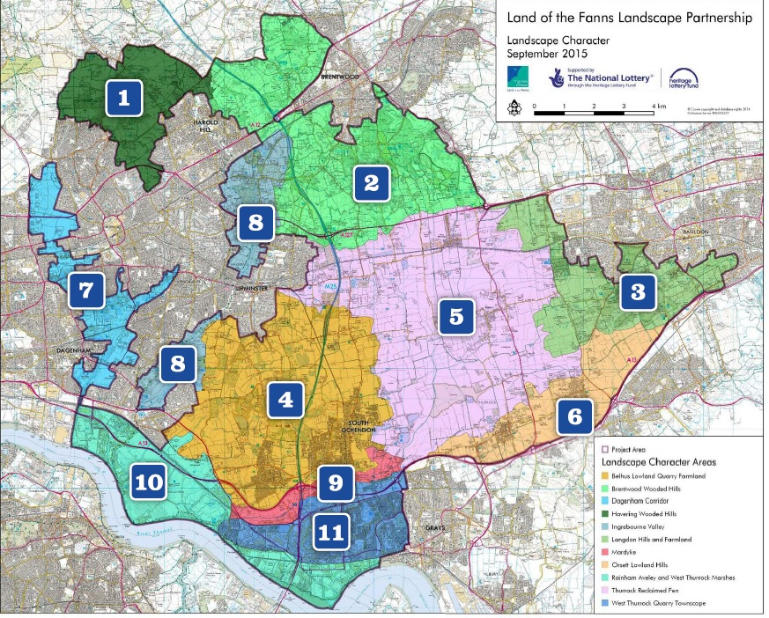
The Land of the Fanns (LotF) Landscape Partnership Scheme area covers 70 square miles from Purfleet in the south to Barking and Dagenham in the west, to Brentwood in the north and Langdon in the east.
For more in depth history of the landscape and background to the LotF Partnership Scheme, please visit our website www.landofthefanns.org/our-landscape/Lcap.
OUR VISION
“The surviving London fans on the edge of East London – a landscape of fens, forest and farms, rich in geological, natural and cultural heritage and continually evolving since the last Ice Age – will be positively managed and understood as the last remaining landscape of London as it once was.
Drawing on the area’s past as a unified, working landscape underpinning London’s growth, the Land of the Fanns will spark a rediscovering of this landscape drawing on the pride local communities instinctively feel about this misunderstood area. This is not only about undertaking restoration and access improvements that reconnect the landscape, it is also about equipping people with better knowledge and understanding to shape the strategic decision making that continues to fragment the landscape.
The landscape is a dynamic one that will continue to change – a broad partnership understanding of the Land of the Fanns will not only enable that change to be more positive, it will also develop its profile as one of the nation’s most fascinating landscapes, intimately connected with one of the most famous and celebrated cities in the world.
The ‘Land of the Fanns’ will become recognised as a connected and cohesive landscape, where its heritage is loved and understood by its people.

OUR OBJECTIVES
Supporting our vision, six strategic objectives were approved by the Land of the Fanns Partnership:
- RESTORATION AND CONNECTION
To work in partnership to restore, conserve and connect the woods, fens, and farmlands, biodiversity, heritage and cultural assets of our landscape and utilize these to support local distinctiveness and pride that reduces further negative impacts.

- ACCESS
To improve physical and intellectual access to the landscape for local communities and visitors
That encourages people to visit, respect and appreciate its natural and built assets, through targeted physical interventions and improved co-ordination of visitor destinations.

- INFORMATION
To create outlets for local knowledge that reveals the exciting and unique stories of the landscape through inclusive methods that enthuses local people and visitors, guides decision-making and celebrates the area.

- EXPERIENCE BY TAKING PART
To encourage people to experience the Land of the Fanns and learn about its rich physical, natural and cultural heritage by actively taking part in conservation projects, research and interpretation activities, cultural activities, events, volunteering and learning that also improves the prospects and skills of local people.

- ENJOYMENT OF THE LANDSCAPE
To develop the Land of the Fanns into a place where local people and visitors can better enjoy the landscape through better co-ordination and commercial thinking of partnership organisations providing tourism and related services.

- PARTNERSHIP WORKING
To build excellent partnership working between the key players who can make the Vision happen – the public sector, private business and the community.

What is the Land of the Fanns Community Action Fund?
The Fund is a grants programme for communities within the Land of the Fanns Project area that compliment the wider delivery scheme and meet some of our main objectives and vision. The intention is to help encourage empowerment and promote a sense of ownership of heritage by local people. Through a grants application process managed by a LotF Community Action Fund Board and the two Commissioning Officers, £15,000 per round will be made available to deliver small-scale projects of up to £5,000.
Who can apply for funding?
In order to be eligible to apply your project must:
- meet the priorities of the Land of the Fanns Community Action Fund programme
- require a grant of up to £5,000 (though the total value of the project can be higher with other funding)
- promote benefits for the public rather than for mainly private gain
- all projects to be deliverable within 1 year of receiving funding.
The following are eligible to apply:
- community groups
- charities (not large national charities)
- not for profit companies
- bids from commercial organisations will be accepted only where the applicant is a small business with a turnover of less than £500,000
- we will accept applications from single organisations and partnerships – for example, a partnership between a heritage/conservation organisation and a community group.
What can we fund?
We can only fund projects that:
- take place within and around the Land of the Fanns Partnership Scheme area
- conform with the Landscape Character Area recommendations and deliver the objectives of the Landscape Conservation Action Plan (this document can be found on the Land of the Fanns website).
By a project we mean work or an activity that:
- is not part of the everyday work of your organisation
- has a schedule for a start and completion and has specific aims.
We can support:
- projects that include capital work (including conservation, repair and related activities)
- activity only projects.
Examples of work we can fund include:
- Restoration and/or sustainable management of landscape features and habitats, e.g. ponds, ditches, hedgerows, woodland, fen, reedbeds etc.

- Engagement of hard to reach groups, e.g. BAME, unemployed, low income, through innovative activities that connect people with their landscape

- Improvement to biodiversity through habitat creation

- Protection, restoration, enhancement and appropriate use of historic built features

- Preservation, restoration and enhancement of archaeological remains

- Educational and recreational initiatives on historic or ecological themes

- Conservation of historic features

- Increased public access where this can be balanced with conservation of landscape fabric, including bridleways, cycling and walking tracks where it is NOT a statutory duty of Local Authority

- Surveying, recording and the monitoring of the archaeology resource or biodiversity

- Interpretation of landscape features, plants, animals and their habitats, built and cultural heritage and geology

- Investigation and recording the human history of the area, especially oral histories of the rural hinterland

- Initiatives to train and develop people’s heritage or ecological, practical skills, e.g. practical conservation, species identification, leading guided walks.
We will NOT give grants for the following works:
- feasibility studies
- schemes in which a significant proportion of costs could be met by other grant schemes
- costs relating to the conversion of buildings for use as dwellings or tourist accommodation
- projects with little or no public benefit (for example conserving buildings in active use for domestic, agricultural or commercial purposes; vehicles, machinery or transport for private use or benefit)
- projects solely involving the purchase of land or buildings
- acquisition of assets in excess of £5,000 value per item, including legal or other transfer costs
- staff costs (unless a new post is created for the project) or organisational running costs
- projects of little clear heritage value (for example sports or leisure facilities, civil engineering work, new roads, bridges or traffic systems, new buildings where existing heritage areas could be adapted)
- academic research
- individual staff and volunteer travel costs
- planning application conditions
- statutory obligations
- costs relating to the preparation of grant applications for this or other schemes, or
- projects where the matched funding is state aid based (such as Environmental Stewardship monies)
- contingency or anything beyond the maximum of £5,000 including VAT.
Other restrictions on funding
We will not fund projects or types of work that are not good practice for the heritage or landscape of the LotF Scheme area. We only fund certain types of work if they form part of a wider project that meets our aims. We cannot fund them as standalone projects. These include:
- visitor facilities such as cafes, car parks and toilets
- putting together or publishing research findings
- creating replicas (models or exact copies) of historic structures or objects
For Collection based projects:
- We will only consider supporting a new museum or other new heritage attraction if it is based on an existing collection recognized as important by the appropriate heritage organisation (for example, the Museums, Libraries and Archives Council in England)
- We will only consider buying heritage items if the item (or most of the collection) is more than 10 years old
Contact us if you are not sure whether we can fund your project.
Ownership Requirements
If you are successful with a grant application, we would normally expect you to either own it or have an agreement with the owner about its use and management and be the only organisation entitled to use any property (land, buildings and heritage items) on which you spend the grant. We will need to see proof of your ownership, as referred to in the list of supporting documents you must send with your application form. If you do not own the property, land or heritage items, you must tell us who does.
Land and Buildings
For projects which involve carrying out capital work to land or buildings, we normally expect you to own the freehold or have a lease with at least 10 years left to run at the date we award any grant. Otherwise, you will need to provide a letter from the owner, saying that you have the owner’s permission to carry out the work. The owner will also need to sign a letter that we will prepare, agreeing to keep to our standard terms of grant.
We would not expect a Community Action Fund grant to involve buying land or buildings. However, if it does, you must buy them either freehold or with a lease with a term of at least 80 years left to run at the date we award any grant.
We do not accept leases with break clauses (these give one or more of the people or organisations involved the right to end the lease in certain circumstances). You must be able to sell on, sublet or mortgage your lease, but if we award you a grant you must first have our permission to do any of these.
Heritage Items
For projects involving buying or carrying out work to a heritage item we expect you to buy or own the item outright.
Intellectual Property
For projects involving, creating or using intellectual property (for example, creating a database, digital images or audio or other multimedia applications) we expect you to get all permissions, waivers and licenses from any other person or organisation who may be entitled to any intellectual property rights which either exist or will be created to allow you to carry out and complete the project in line with your application. We reserve the right to request copies of any such permissions, waivers or licenses.
Permissions
You will be required to find out whether elements of your project require specific permission. Permissions do not necessarily need to be in place before you apply but supplying evidence of permission may be made a condition of any grant offered.
Examples of permissions that may be required include:
- Planning permission
- Listed building consent
- Scheduled Ancient Monument consent
- Site of Special Scientific Interest consent
- Environmental Permit for Flood Risk Activities

Your application and when to apply
What to Read
As well as this document and the help notes on the application form, we would advise that you read the relevant sections of the Landscape Conservation Action Plan, including the Landscape Character Area relevant to your project. This documentation is all found on the Land of the Fanns website: www.landofthefanns.org.
Please contact the Commissioning Officers (contact details below) should you need clarification.
How do we apply?
You apply by completing the application form electronically or manually. The form can be signed electronically.
If more space is needed when completing the form manually, please use extra blank sheets (clearly headed) for each section. Please write clearly and in ink.
Save, or copy, a version of your completed form for yourself before sending.
Send the form with any supporting documents to the Commissioning Officers.
Once you have sent your application to our office, we will acknowledge receipt.
Applications can be sent in within the dates shown below:
Round 1 7th February 2018 – 31st July 2018
Round 2 1st September 2018 – 31st January 2019
Round 3 1st March 2019 – 31st July 2019
Round 4 1st September 2019 – 31st January 2020
Round 5 1st March 2020 – 31st July 2020
All projects to be finished by September 2021
The CAF Board will make decisions in February and August each year and applicants will be notified of the outcome very soon afterwards. The CAF Board’s decision is final and cannot be appealed.
All Community Action Fund grants must be spent and reported to Land of the Fanns Commissioning Officers within a year from you receiving your award.
How much can we apply for?
Each organisation / community group may apply for up to £5,000 for their project. If your project goes over the maximum amount, we may still award our grant but you will have to get funding from other sources. However, the amount you are applying for from our Community Action Fund must still adhere to all the conditions set out in these guidelines and on the application form.
What are the monitoring requirements?
We will expect your group to provide us with evidence within the first 6 weeks of your project start date by photos and a brief progress report. Regular visits will also be made by the Commissioning Officers for monitoring purposes. Please do contact us immediately if there are any delays or problems with the project.
What we will assess
When the Board assesses your application, we will take account of the value for money your project offers, the overall benefits of the project in relation to the costs, and the amount of grant you want from us. We will also assess how far your application shows that:
- Your project supports relevant landscape guidelines for the LotF area
- Your project is an appropriate response to a need or opportunity
- Your project engages with the community
- Your project is well planned and your proposals for managing it are sound
- Your organisation is capable of carrying out the project within 1 year
- Your project is financially realistic and there is a clear need for funding
- Your project is sustainable beyond the level of funding
- Your project promotes far greater levels of public benefit than private gain.
What supporting documents will I need to include in my application?
- Copy of your organisation’s constitution (formal rules) unless you are a public organisation or commercial business
- Copies of deeds, leases, mortgages or other proof of ownership, or agreement from land owner if your project involves work to land, buildings or heritage items
- A small selection of photos or drawings that will help illustrate your project
- Letters of support (no more than 6) from other organisations. They should be specific to the project rather than general letters of support
- Job descriptions for any new staff positions included in your grant request
- Signed copy of most recent accounts or bank statements.

Successful Applications
Managing your grant
If your application is successful we will send you a formal grant offer letter, together with a contract for you to sign and return to us. You will be able to start your project as soon as you have our written permission and all other funding is in place.
Some successful applications will be conditional upon receiving additional information at the discretion of the grant Board. Examples of this may be a child protection policy or additional information on costing.
How will our grant be paid?
We will pay 100% of your application grant upfront once you have received our permission to start your project.
Awards are paid direct by BACS into the nominated bank account.
What happens if not all the grant award monies are spent?
UNSPENT FUNDS MUST BE RETURNED TO THAMES CHASE TRUST IMMEDIATELY ON COMPLETION OF YOUR PROJECT (one year from receiving your fund award).
Publicity and acknowledgement
Public support, understanding and appreciation are vital to the success of the Land of the Fanns Landscape Partnership Scheme and the Community Action Fund Grant.
If we give you a grant, you must publicise and acknowledge it. We may use your project on our own LotF website and other social media. We may also promote your project as widely as possible to:
- Make sure that the public understand the project
- Make sure that people have opportunities to take part
- Contribute to the sustainability of the project
- Ensure that Land of the Fanns Partnership Scheme and Heritage Lottery Fund contribution is recognised.
Acknowledgement of your grant must be clear to all visitors using your site, on publications or displays, or to people taking part in your activities.
Other information
Freedom of Information
We have a duty to adhere to the Freedom of Information Act 2000. When you sign the declaration at the end of the application form, you are confirming that you have no objection to us releasing details from the application form to anyone who asks to see them. If there is any information in the form that you do not want made publicly available, please say in the space provided and explain your reasons. We will take these into account when we respond to any request for information. However, we will always consult you first and will take account of your rights and expectations under the Freedom of Information Act 2000 and Data Protection Act 2018.
Data Protection Act
Under the Data Protection Act 2018, we will process personal information relating to your organisation, its officers and staff or any other people you refer to in your application, for:
- Assessing your grant application and how we handle it
- Handling the terms of your grant
- Sharing information with our specialists and monitors
- Keeping you informed of our work
- Publicising information about your application
- Research related to your application
- Other legal or regulatory purposes or other purposes reasonably related to making grants.

Commissioning Officers: Aisling Woodhead aisling.woodhead@thameschase.org.uk
Debbie Brady deborah.brady@thameschase.org.uk
Telephone 01708 642977 / 78
Land of the Fanns Landscape Partnership Scheme
Thames Chase Forest Centre,
Pike Lane,
Upminster, RM14 3NS

