FOR OFFICE USE ONLY | Date Received: LotF REF:
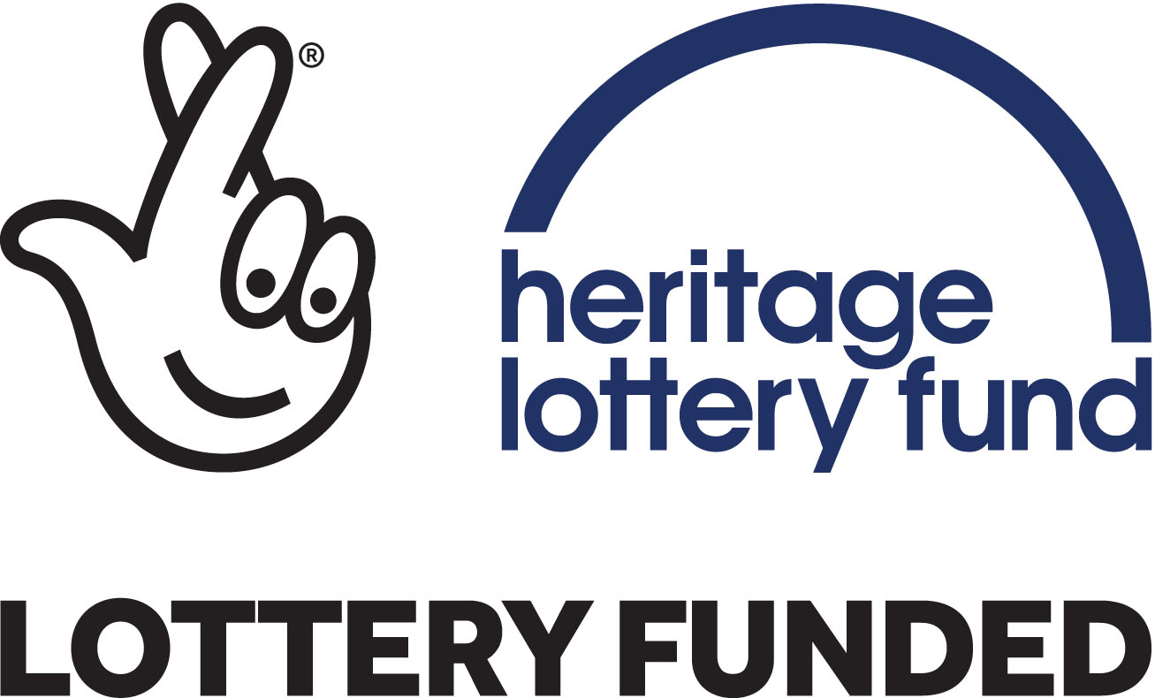
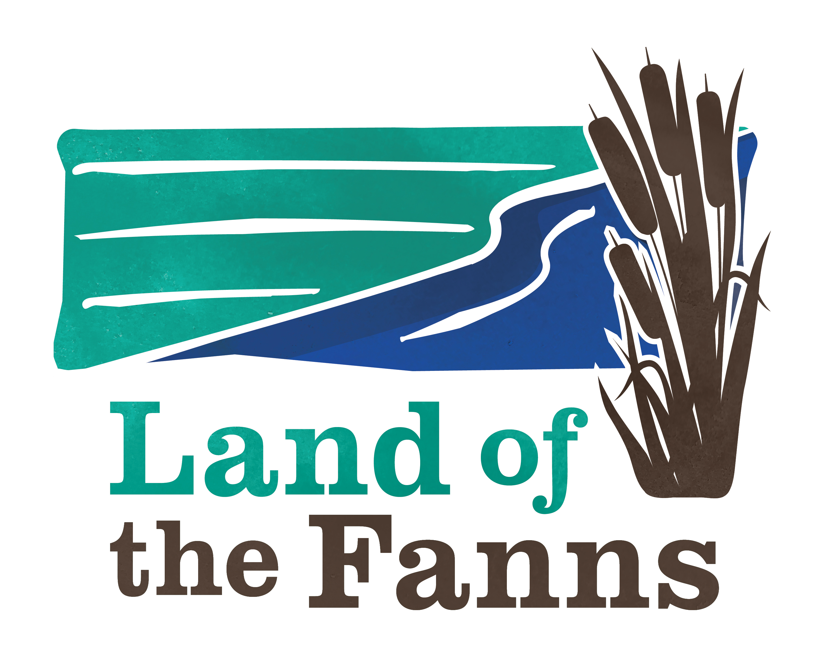
Community Action Fund
Application Form

Please read the Background Information & Guidance Notes and Frequently Asked Questions before completing your application.

Section 1 | Contact details
Name of group
Full Postal Address
Main contact name  (person who can talk about detail of your application) |  |  | Position in group
Telephone (landline) |  |  | Telephone (mobile)
E-mail Address
Section 2 | Organisation status (mark X accordingly)
Group type | Registered Charity (please state charity no: )
Group type | ‘Not for Profit’ Voluntary & Community Sector Group
Group type | Private Individual
Group type | Social Enterprise
Group type | Local Authority
Group type | Parish or Town council
Group type | Other

Section 3 | Organisation details
Please briefly explain your organisation’s main services and/or activities:

Section 4 | Which of our programme objectives does your project support?
Refer to Objectives in Guidance Notes for fuller descriptions. Your project must meet one at least one of the objectives. (mark X accordingly)
- Restoration and Connection |  |  | - Experience by taking part
- Access |  |  | - Enjoyment of the Landscape
- Information |  |  | - Partnership working

Section 5 |  | What is your Project?
Please describe the project in no more than 100 words. We may use this on our website or for other publicity purposes:

How did you get the idea for your project?

How do you know there is a need or demand for your project?

Project Plan
- Tell us in more detail what you plan to do
- Answer the questions below and add any other headings as relevant to your project
- Try to be specific and include numbers of people involved, number of events and locations of activities
- Find out more about our objectives and positive actions for Landscape Character areas in the Landscape Conservation Action Plan on the Land of the Fanns website: www.landofthefanns.org/our-partnership/partner-resources/

When will your project take place?

Where will your project take place?

Who will be working on your project?

How many volunteers (if any) will be involved?

How will you be engaging with the community?

Who will benefit?

How is the project sustainable once the funding ends?

What will happen to any items that your project has produced? (for example, if you produced an exhibition what happens to it?)

How will you manage your project?
Tell us about the skills and experience of the person who will lead your project and of the people in the team.
Identify any training that will be necessary for or will improve the delivery of the project, whether staff, volunteers or local communities.

When will your project start and finish?
You should start and finish your project within 1 year of being awarded a Community Action Fund Grant.

Your timetable should allow enough time for us to assess your application. You can approximate your start date from the month each year the CAF Board decisions are made, see Guidance Notes, and a date when you can realistically start after a successful application award.

Start date: ............................................(approx) Finish date: ..........................................(approx)

Section 6 |  | Financial information
How much money are you applying for from the Community Action Fund? (total inclusive of VAT) |  |  |  | £
What is the total cost of your project? |  |  |  | £
Please provide a budget breakdown of all costs related to your Community Action Fund application only:
Budget breakdown – please list costs (add additional boxes as required) |  |  |  | Amount £
If the request is less than the total cost, please detail below how will you fund the difference
Total contribution from your own current resources |  |  |  | £
Total raised from forthcoming fundraising activities (estimated) |  |  |  | £
Total in kind contributions e.g. volunteer time |  |  |  | £
Total secured match funding from other funders |  |  |  | £
Please list the names of other funders you have applied to, amount applied for and the expected date of outcome:

If you have any other sources of funding, please detail them here:

Section 7 | Payment Arrangements  (sort code and bank account number will be requested if your application is successful)
Named person /group on Account
Name of Bank
Branch location
Non-constituted groups will have their award paid to the group’s nominated persons bank as agreed with the Commissioning Officers (or intermediary organisations bank).

Section 8 | How did you find out about the Land of the Fanns Community Action Fund? (mark X accordingly)
Website |  | Poster/Leaflet | Magazine /local press |  | LotF Staff Member
Previous Applicant |  | Social Media | LotF Event |  | Other (see below)
If other, please provide details:
Section 9 | Signatory
Declaration:
- I have read and understood the Guidance Notes. I agree that you can check the information in this application and any supporting documents with other people and organisations.
- My organisation has the power to accept a grant, under your terms, and the power to pay back the grant if the terms are not met.
- I understand that any misleading statements (whether deliberate or accidental) I give at any point during the application process, or any information I knowingly withhold, could mean my organisation’s application is not valid, in which case you will cancel the grant and request back the money you offered my organisation.
- I am authorised to put forward this application on behalf of my organisation.
- On behalf of my organisation, I agree that if we receive any grant from you for our project, we will keep to the standard terms of grant and any further terms and conditions set out in the grant notification letter.

Signed |  |  | Print
Status in group
On behalf of (group name)
Date

Section 10 | Data protection notice
The Land of the Fanns Landscape Partnership Scheme will use the information provided on this form for the form’s stated purpose. No personal information you have given us will be passed on to third parties for commercial purposes. The policy is that all information will be shared among officers across departments and other agencies, where the legal framework allows, if this will help to improve the service you receive and to develop other services.
Please mark this box (X) if you do not consent to the Land of the Fanns Landscape Partnership Scheme processing your information in this way where it considers it to be appropriate.
The Land of the Fanns Landscape Partnership Scheme is under duty to protect the public funds it administers, and to this end may use the information you have provided on this form for the prevention and detection of fraud. It may also share this information with other bodies responsible for auditing or administering public funds for these purposes.

Please ensure you include the following documents with your completed application:
- Copy of your organisation’s constitution (formal rules), unless you are a public organisation, private individual or commercial business.
- Copies of deeds, leases, mortgages or other proof of ownership if your project involves work to land, buildings or heritage items or agreements with landowners allowing permission to undertake work on their land.
- Signed copy of most recent accounts or bank statements (not required for local authorities).
- Copy of Equality & Diversity Policy
- Copy of Public Liability Insurance (if applicable)
- Three quotes (if applicable, see Frequently Asked Questions)
- Letters of support (no more than six) from other organisations. They should be specific to the project rather than general letters of support. (Informal groups only)
- A small selection of photos or drawings that will help to illustrate your project.

If you require any advice or further information regarding your application, please email the Commissioning Officers or telephone 01708 642977/ 642978.
Post your completed application form to:
Land of the Fanns Landscape Partnership Scheme
Thames Chase Forest Centre
Pike Lane
Upminster RM14 3NS

or email:
deborah.brady@thameschase.org.uk aisling.woodhead@thameschase.org.uk

