Land of the Fanns
Landscape Intervention Fund
Background Information & Guidance Notes
We strongly recommend that you read this document before completing the application form.
Application forms can also be found at: https://www.landofthefanns.org/projects/a1-1-landscape-management-plan/
What is the Landscape Intervention Fund?
The intervention fund is a grants programme for landowners and managers within the Land of the Fanns Project area that complement the wider scheme delivery and meet some of our main objectives and vision. The intention is to deliver small scale landscape improvements within the farmed landscape.
Who can apply for funding?
In order to be eligible to apply your project must:
- meet the priorities of the Land of the Fanns
- require a grant of up to £1,000 (though the total value of the project can be higher with other funding)
- all projects to be deliverable by June 2022
What can we fund?
We can only fund projects that:
- take place within and around the Land of the Fanns Partnership Scheme area
- conform with the Landscape Character Area recommendations (see appendix for map) and deliver the objectives of the Landscape Conservation Action Plan (this document can be found on the Land of the Fanns website)
Examples of work we can fund include:
We will consider each application on a case by case basis with grants capped at £1,000. Examples of projects we can fund include:
- Restoration and/or sustainable management of landscape features and habitats, e.g. ponds, ditches, hedgerows, woodland, fen, reedbeds etc.
- Improvement to biodiversity through habitat creation
- Protection, restoration, enhancement and appropriate use of historic built features preservation, restoration and enhancement of archaeological remain
- Conservation of historic features
- Increased public access where this can be balanced with conservation of landscape fabric, including bridleways, cycling and walking tracks where it is NOT a statutory duty of Local Authority
- Surveying, recording and the monitoring of the archaeology resource or biodiversity
- Contribution towards production of Countryside Stewardship application

Table of interventions and payment rates*
Option | Intervention rate
Nectar flower mix | £562.10 per hectare
Winter bird food | £704 per hectare
Planting new hedge | £12.76 per metre
Hedge laying | £10.34 per metre
Flower rich margins & plots | £592.90 per hectare
Autumn sown bumblebird mix | £605 per hectare
Supplementary winter bird feeding | 695.20 per tonne over 2Ha
Gapping up hedge | £10.45 per metre
Small leaky woody dams | £507.52 per dam
Plant standard hedgerow tree | £9.68 per tree
Small wildlife box | £31.35 per box
Medium wildlife box | £42.90 per box
Large wildlife box | £110 per box
Pond management | £113.30 per pond first 100m2
Pond management | £201.30 per pond more than 100m2

*We will also consider bespoke projects where these have been agreed in advance with Land of the Fanns

Contact us if you are not sure whether we can fund your project.
Ownership Requirements
If you are successful with a grant application, we would normally expect you to either own it or have an agreement with the owner about its use and management and be the only organisation entitled to use any property (land, buildings and heritage items) on which you spend the grant. We will need to see proof of your ownership, as referred to in the list of supporting documents you must send with your application form. If you do not own the property, land or heritage items, you must tell us who does.
Land and Buildings
For projects which involve carrying out capital work to land or buildings, we normally expect you to own the freehold or have a lease with at least 10 years left to run at the date we award any grant. Otherwise, you will need to provide a letter from the owner, saying that you have the owner’s permission to carry out the work. The owner will also need to sign a letter that we will prepare, agreeing to keep to our standard terms of grant.
We would not expect the grant to involve buying land or buildings. However, if it does, you must buy them either freehold or with a lease with a term of at least 80 years left to run at the date we award any grant.
We do not accept leases with break clauses (these give one or more of the people or organisations involved the right to end the lease in certain circumstances). You must be able to sell on, sublet or mortgage your lease, but if we award you a grant you must first have our permission to do any of these.
Permissions
You will be required to find out whether elements of your project require specific permission. Permissions do not necessarily need to be in place before you apply but supplying evidence of permission may be made a condition of any grant offered.
Examples of permissions that may be required include:
- Planning permission
- Listed building consent
- Scheduled Ancient Monument consent
- Site of Special Scientific Interest consent
- Environmental Permit for Flood Risk Activities

Your application and when to apply
What to Read
As well as this document and the help notes on the application form, we would advise that you read the relevant sections of the Landscape Conservation Action Plan, including the Landscape Character Area relevant to your project. This documentation is all found on the Land of the Fanns website: www.landofthefanns.org.
Please contact the Commissioning Officers (contact details below) should you need clarification.
How do we apply?
You apply by completing the application form electronically or manually. The form can be signed electronically.
If more space is needed when completing the form manually, please use extra blank sheets (clearly headed) for each section. Please write clearly and in ink.
Save, or copy, a version of your completed form for yourself before sending.
Once you have sent your application to our office, we will acknowledge receipt.
Closing date for new applications is March 2022
All projects to be finished by June 2022
LotF will usually make a decision on new applications on a case by case basis and applicants will be notified of the outcome very soon afterwards. The decision is final and cannot be appealed.
All grants must be spent by June 2022 and outputs reported to Land of the Fanns.
How much can we apply for?
Each landowner may apply for up to £1,000 for their project. If your project goes over the maximum amount, we may still award our grant but you will have to get funding from other sources. However, the amount you are applying for the intervention fund must still adhere to all the conditions set out in these guidelines and on the application form. On completion of the project we would expect a short report detailing the outputs.
What are the monitoring requirements?
We will expect you to provide us with evidence within the first 6 weeks of your project start date by photos and a brief progress report. Regular visits will also be made by RSPB or members of the LotF team for monitoring purposes. Please do contact us immediately if there are any delays or problems with the project. On completion of the project we would expect a short report detailing the outputs.

Successful Applications
Managing your grant
If your application is successful we will send you a formal grant offer letter, together with a contract for you to sign and return to us. You will be able to start your project as soon as you have our written permission and all other funding is in place.
Some successful applications will be conditional upon receiving additional information at the discretion of the grant Land of the Fanns. Examples of this may be additional information on costing.
How will our grant be paid?
We will pay 50% of your application grant upfront once you have received our permission to start your project. The remaining 50% will be paid upon completion of your project.
Awards are paid direct by BACS into the nominated bank account.
What happens if not all the grant award monies are spent?
UNSPENT FUNDS MUST BE RETURNED TO THAMES CHASE TRUST IMMEDIATELY ON COMPLETION OF YOUR PROJECT
Publicity and acknowledgement
Public support, understanding and appreciation are vital to the success of the Land of the Fanns Landscape Partnership Scheme and the Intervention fund
If we give you a grant, you must publicise and acknowledge it. We may use your project on our own LotF website and other social media. We may also promote your project as widely as possible to:
- Make sure that the public understand the project
- Make sure that people have opportunities to take part
- Contribute to the sustainability of the project
- Ensure that Land of the Fanns Landscape Partnership Scheme and National Lottery Heritage Fund contribution is recognised.
Acknowledgement of your grant must be clear to all visitors using your site, on publications or displays, or to people taking part in your activities.
Other information
Freedom of Information
We have a duty to adhere to the Freedom of Information Act 2000. When you sign the declaration at the end of the application form, you are confirming that you have no objection to us releasing details from the application form to anyone who asks to see them. If there is any information in the form that you do not want made publicly available, please say in the space provided and explain your reasons. We will take these into account when we respond to any request for information. However, we will always consult you first and will take account of your rights and expectations under the Freedom of Information Act 2000 and Data Protection Act 2018.
Data Protection Act
Under the Data Protection Act 2018, we will process personal information relating to your organisation, its officers and staff or any other people you refer to in your application, for:
- Assessing your grant application and how we handle it
- Handling the terms of your grant
- Sharing information with our specialists and monitors
- Keeping you informed of our work
- Publicising information about your application
- Research related to your application
- Other legal or regulatory purposes or other purposes reasonably related to making grants.
If you require any advice or further information regarding your application, please email howard.vaughan@rspb.org.uk or aisling.woodhead@thameschase.org.uk

Appendix
Background
It was Leslie Thompson who first coined the phrase, ‘The Land that Fanns’ in his local history study in 1957 which celebrates a more unified landscape. ‘Fanns’ is derived from the Saxon word for fen which meant ‘low marshy land or low-lying district’ which perfectly describes much of the area. There are frequent references in his book to the fann men of this area; their work in managing this marshy landscape and their lifestyle during the 17th and 18th centuries, taken from local parish records from Rainham in the west to Canvey Island in the east. Thompson was amused by the fact that the land even appears to fan out from the panoramic view at Langdon Hills and hence gave rise to his book title.
Shaped by the ice age and historically an area of fens, forests and farming, the landscape hosts an unusual variety of niche landscapes including highland, lowland, marshes and river valleys. Each of its 11 landscape character areas has attracted its own history, collectively making up a surprising landscape of diverse heritage with sites of national importance often overlapping with the national story.
The landscape is rich in heritage from landscape to biodiversity; to its buildings and archaeology, as well as its human communities, including the arts, religion and engineering.
Whilst the project has taken this phrase and used it to cover an area encompassing more than just historic fenland, the title still retains a ring of truth about it. Indeed the wider landscape owes so much of its character to a marshy origin that it becomes appropriate. By adopting the historic name coined locally for this area, the ‘Land of the Fanns’ also captures the essence of the project’s ambition: to reunify the landscape and spark renewed attachment to it. We want to take our landscape partners and communities on a five year journey to build understanding, strengthen attachment and celebrate what is special about our area and to leave a lasting legacy for future generations.
About the Land of the Fanns Partnership Scheme
The partnership is made up of 5 local councils, The London Borough of Barking and Dagenham, The London Borough of Havering, Thurrock Council, Essex County Council and Brentwood Council and joined by partner organisations such as Thames Chase Trust (Lead partner), Forestry Commission, Thames21 and Thames Estuary Partnership.

Map showing the Land of the Fanns Landscape Project Area.
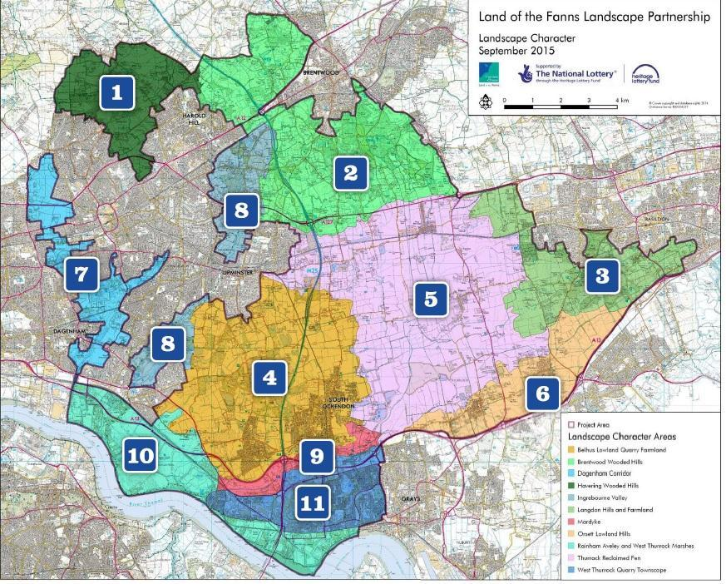
The Land of the Fanns (LotF) Landscape Partnership Scheme area covers 70 square miles from Purfleet in the south to Barking and Dagenham in the west, to Brentwood in the north and Langdon in the east.
For more in depth history of the landscape and background to the LotF Partnership Scheme, please visit our website www.landofthefanns.org/our-landscape/Lcap.
OUR VISION
“The surviving London fans on the edge of East London – a landscape of fens, forest and farms, rich in geological, natural and cultural heritage and continually evolving since the last Ice Age – will be positively managed and understood as the last remaining landscape of London as it once was.
Drawing on the area’s past as a unified, working landscape underpinning London’s growth, the Land of the Fanns will spark a rediscovering of this landscape drawing on the pride local communities instinctively feel about this misunderstood area. This is not only about undertaking restoration and access improvements that reconnect the landscape, it is also about equipping people with better knowledge and understanding to shape the strategic decision making that continues to fragment the landscape.
The landscape is a dynamic one that will continue to change – a broad partnership understanding of the Land of the Fanns will not only enable that change to be more positive, it will also develop its profile as one of the nation’s most fascinating landscapes, intimately connected with one of the most famous and celebrated cities in the world.
The ‘Land of the Fanns’ will become recognised as a connected and cohesive landscape, where its heritage is loved and understood by its people.
OUR OBJECTIVES
Supporting our vision, six strategic objectives were approved by the Land of the Fanns Partnership:
- RESTORATION AND CONNECTION
To work in partnership to restore, conserve and connect the woods, fens, and farmlands, biodiversity, heritage and cultural assets of our landscape and utilize these to support local distinctiveness and pride that reduces further negative impacts.

- ACCESS
To improve physical and intellectual access to the landscape for local communities and visitors
That encourages people to visit, respect and appreciate its natural and built assets, through targeted physical interventions and improved co-ordination of visitor destinations.

- INFORMATION
To create outlets for local knowledge that reveals the exciting and unique stories of the landscape through inclusive methods that enthuses local people and visitors, guides decision-making and celebrates the area.

- EXPERIENCE BY TAKING PART
To encourage people to experience the Land of the Fanns and learn about its rich physical, natural and cultural heritage by actively taking part in conservation projects, research and interpretation activities, cultural activities, events, volunteering and learning that also improves the prospects and skills of local people.

- ENJOYMENT OF THE LANDSCAPE
To develop the Land of the Fanns into a place where local people and visitors can better enjoy the landscape through better coordination and commercial thinking of partnership organisations providing tourism and related services.

- PARTNERSHIP WORKING
To build excellent partnership working between the key players who can make the Vision happen – the public sector, private business and the community.

